Principles of Design Assignment

🡪 Seanhalpin.io homepage

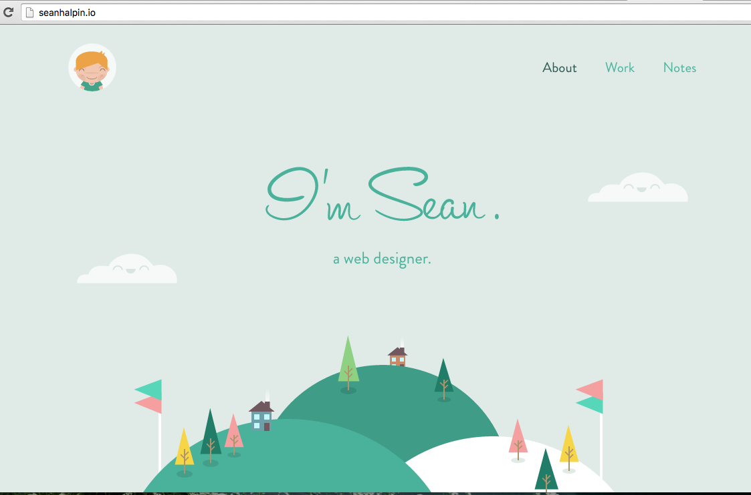

* First, this portfolio website is a very good example of having a good **Signal-to-Noise Ratio**. The design is very simple and there are only three tabs from which to choose from when you first arrive on the page.
* Second, it is a good example of **Hick's Law**. Hick's Law states that the user should always try to reduce the number of decisions involved. This website has only three decision and you start out on one of them.

🡪Seanhalpin.io homepage continued…

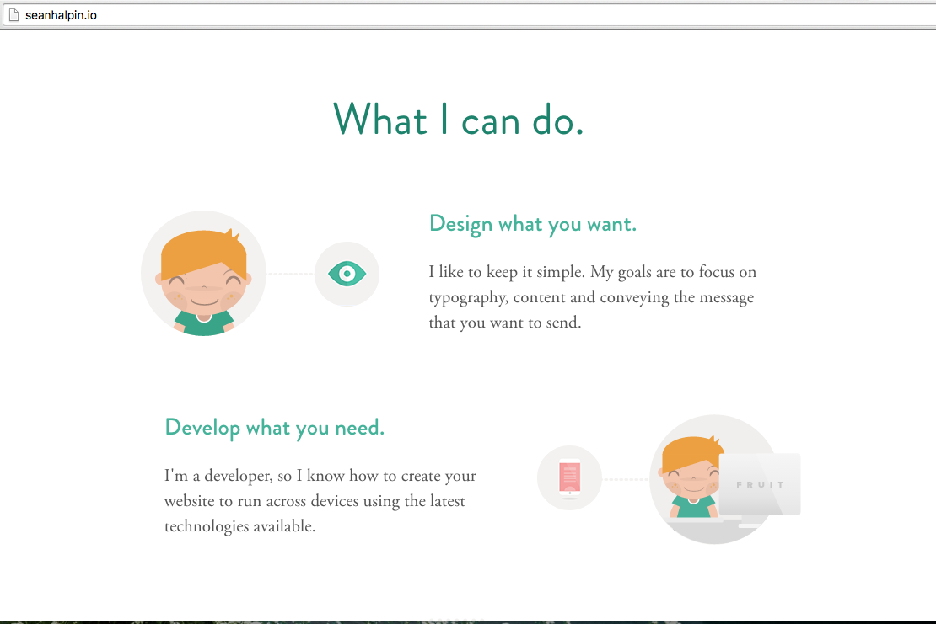

* This screenshot is a good example of how to effectively **Chunk** important information. Sean keeps it clear and concise and chunks together his information for easy and quick reading for the user.

🡪Seanhalpin.io homepage continued…

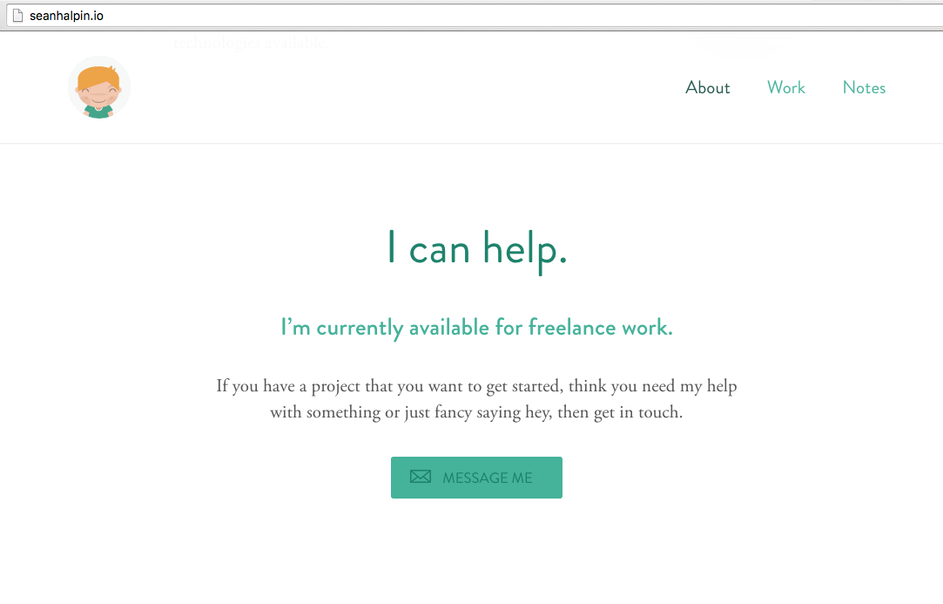

* Sean’s use and placement of the "Message Me" button is a good use of the **Mapping** principle. It has one function and fits in with the layout of the rest of the homepage.
* Along with that, the design of his "Message Me" button is also a good use of the **Affordance** principle. It has a little mail symbol, a box around the words, "Message Me" and that box is a different color than the rest of the background, while still being designed to go with the theme of the homepage.